**Ideation Phase**

**Brainstorm & Idea Prioritization Template**

|  |  |
| --- | --- |
| Date | 27 June 2025 |
| Team ID | LTVIP2025TMID31107 |
| Project Name | Sustainable smart city assistant using IBM granite LLM |
| Maximum Marks | 4 Marks |

**.**

**Sustainable Smart City Assistant Using IBM Granite LLM**

Project Overview

The Sustainable Smart City Assistant is an AI-powered platform that leverages IBM Watsonx's Granite LLM and modern data pipelines to support urban sustainability, governance, and citizen engagement. It integrates several modules like City Health Dashboard, Citizen Feedback, Document Summarization, Eco-Advice, Anomaly Detection, KPI forecasting and Chat Assistant through a modular FastAPI backend and a Streamlit.

Step-1: Team Gathering, Collaboration and Select the Problem Statement

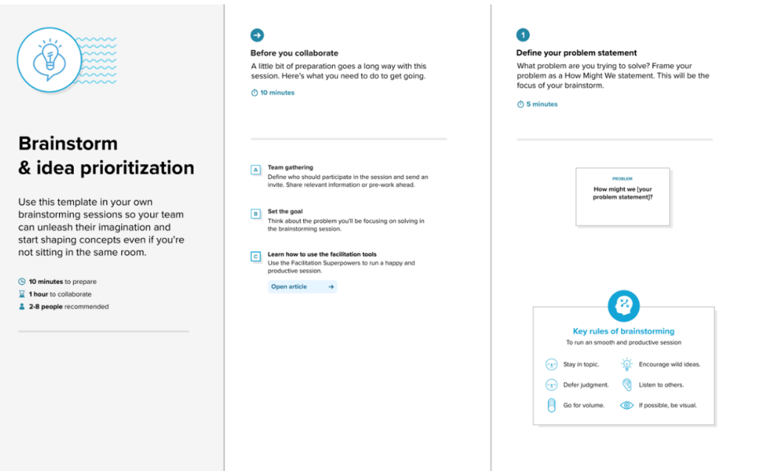

Step-2: Brainstorm, Idea Listing and Grouping

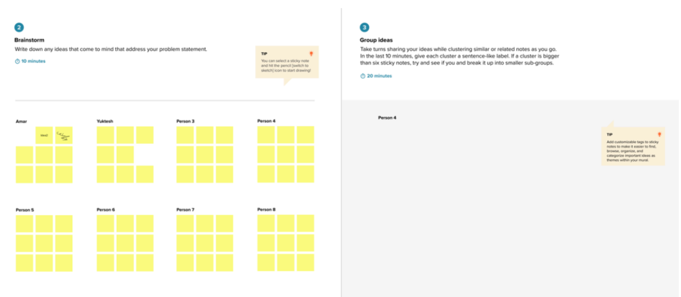

Step-3: Idea Prioritization

